

Partner bootcamp

Table of ContentS

[1 Overview 3](#_Toc42703106)

[2 Shopping Cart 4](#_Toc42703107)

[2.1 Shopping Cart – select category 5](#_Toc42703108)

[2.2 Shopping Cart – select product 6](#_Toc42703109)

[2.3 Shopping Cart – add product to cart 7](#_Toc42703110)

[2.4 Shopping Cart – select product 8](#_Toc42703111)

[2.5 Shopping Cart – add product to cart 9](#_Toc42703112)

[2.6 Shopping Cart – go back to categories 10](#_Toc42703113)

[2.7 Shopping Cart – select category 11](#_Toc42703114)

[2.8 Shopping Cart – select product 12](#_Toc42703115)

[2.9 Shopping Cart – add product to cart 13](#_Toc42703116)

[2.10 Shopping Cart – add product to cart 13](#_Toc42703117)

[2.11 Shopping Cart – Proceed checkout 14](#_Toc42703118)

[2.12 Shopping Cart – checkout step 1: items validation 14](#_Toc42703119)

[2.13 Shopping Cart – checkout step 2: payment type choice 15](#_Toc42703120)

[2.14 Shopping Cart – checkout step 2: payment type validation 15](#_Toc42703121)

[2.15 Shopping Cart – checkout step 3: details for cash delivery 15](#_Toc42703122)

[2.16 Shopping Cart – checkout step 3: details for cash delivery validation 16](#_Toc42703123)

[2.17 Shopping Cart – checkout step 4: Invoice address 16](#_Toc42703124)

[2.18 Shopping Cart – checkout step 4: Invoice address validation 17](#_Toc42703125)

[2.19 Shopping Cart – checkout step 5: Delivery type choice 17](#_Toc42703126)

[2.20 Shopping Cart – checkout step 5: Delivery type validation 17](#_Toc42703127)

[2.21 Shopping Cart – order summary 18](#_Toc42703128)

[2.22 Shopping Cart – order confirmation 18](#_Toc42703129)

[2.23 Shopping Cart – order completed 19](#_Toc42703130)

[2.24 Shopping Cart – select order number 19](#_Toc42703131)

[2.25 Shopping Cart – return to shop 20](#_Toc42703132)

[2.26 Shopping Cart – home 20](#_Toc42703133)

[3 Email 21](#_Toc42703134)

[3.1 Email – send the order number 21](#_Toc42703135)

[4 Summary 22](#_Toc42703136)

# 1 Overview

**Estimated time:** [provide a time] minutes   
  
**Objective**

*In the following document you will find the use case you have to automate: purchase order in Shopping cart application*

**Exercise Description**

overview of the objectives that will be executed during the exercise:

* *Capture the application, declare the pages and items*
* *Create the needed workflows*
* *Create UIs and dashbords if needed*
* *Handle errors and timeouts*
* *Additional infos in restitution*

# 2 Shopping Cart

*In the following document you will find the use case you have to automate: purchase order in Shopping cart application*

[https://openui5.hana.ondemand.com/1.73.2/test-resources/sap/m/demokit/cart/webapp/index.html#](https://openui5.hana.ondemand.com/1.73.2/test-resources/sap/m/demokit/cart/webapp/index.html)

During this exercise, you have to create an automation that adds products in a shopping cart. The products to add must be found in an extern CVS file. At the end, you submit the purchase order.

Product CVS file has following structure:

| Name | Price | Category |
| --- | --- | --- |
| Flat Watch HD32 | 1459 | Flat Screen TVs |
| Flat Watch HD41 | 899 | Flat Screen TVs |
| Benda Laptop 1408 | 976 | Laptops |

Further requirements and tips:

* The bot will be launched using a menu in the systray
* Do not use the URLs to navigate between pages, use only buttons and links

 You will find in the next sections the precise actions your automation has to perform.

# 2.1 Shopping Cart – select category

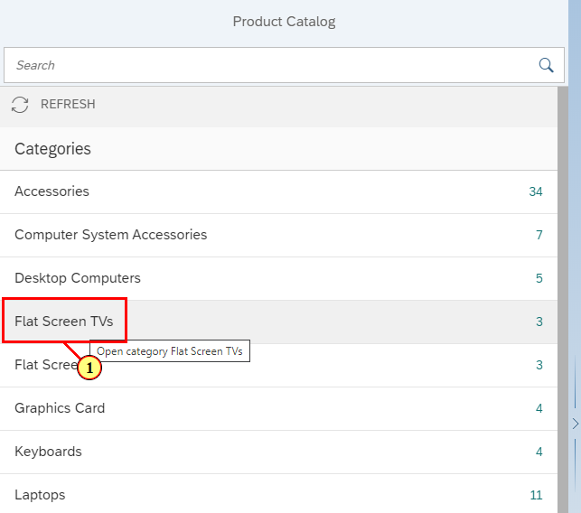

(1)  Click fieldicon_314

# 2.2 Shopping Cart – select product

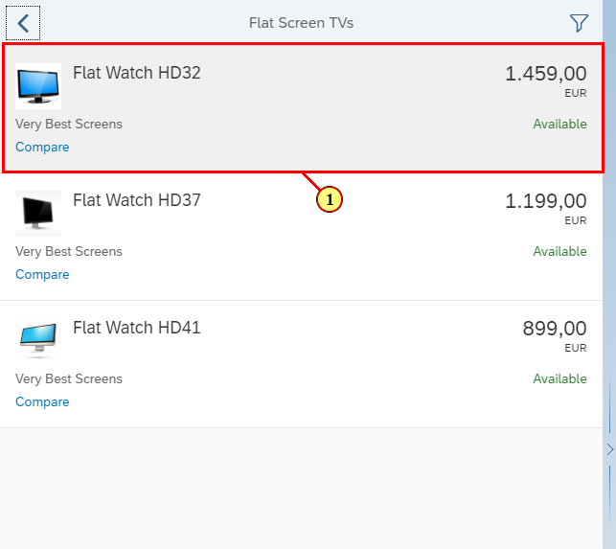

(1) Click 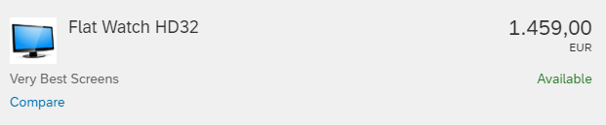

# 2.3 Shopping Cart – add product to cart

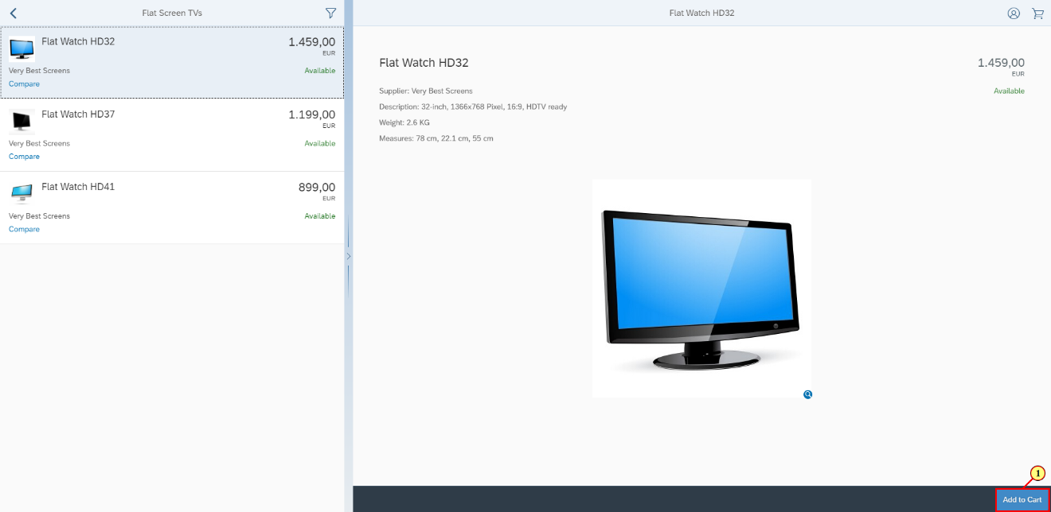

(1) Click fieldicon.

# 2.4 Shopping Cart – select product

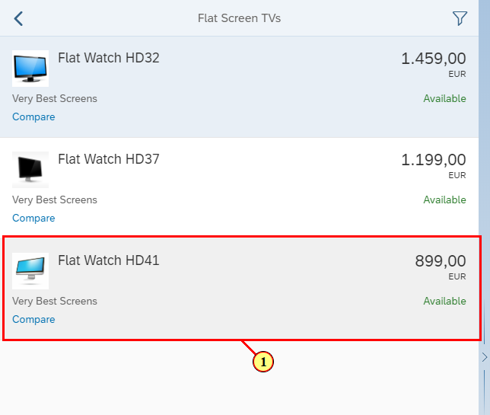

(1) Click 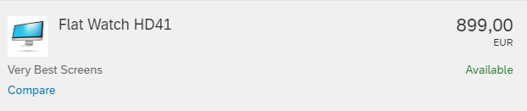.

# 2.5 Shopping Cart – add product to cart

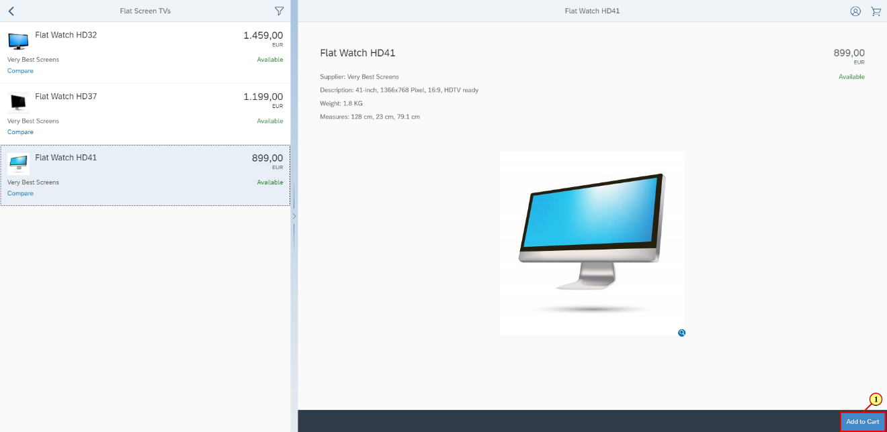

(1) Click fieldicon.

# 2.6 Shopping Cart – go back to categories

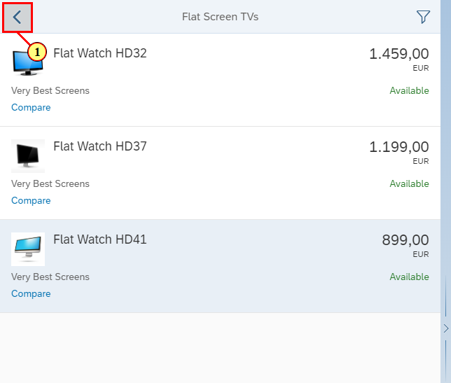

(1) Click fieldicon.

# 2.7 Shopping Cart – select category

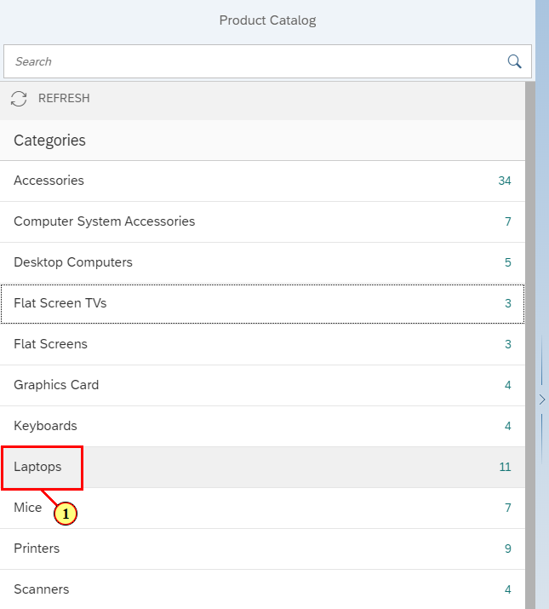

(1) Click fieldicon_322.

# 2.8 Shopping Cart – select product

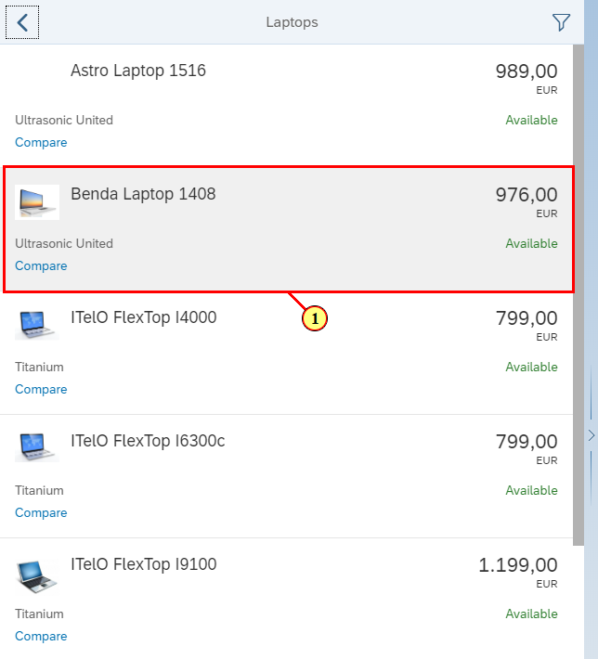

(1) Click 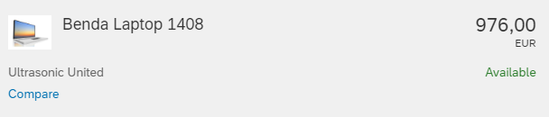.

# 2.9 Shopping Cart – add product to cart

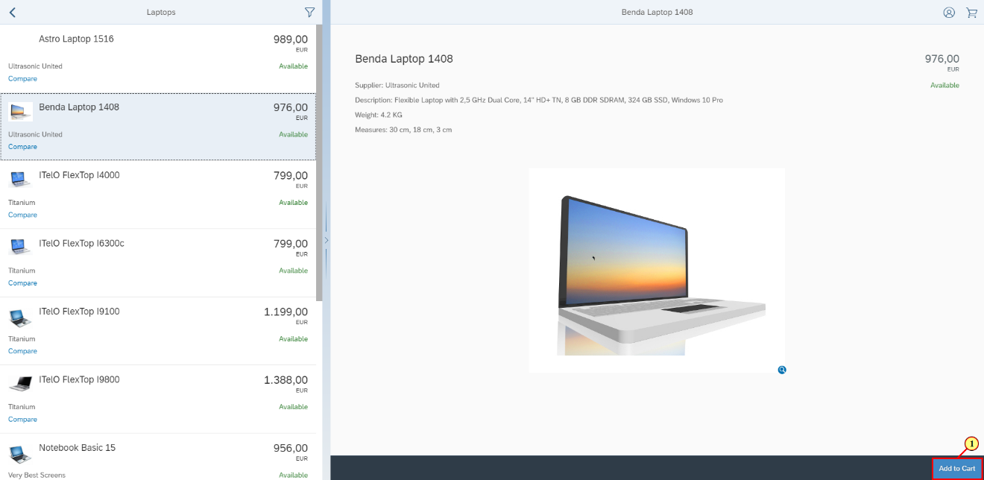

(1) Click fieldicon.

# 2.10 Shopping Cart – add product to cart

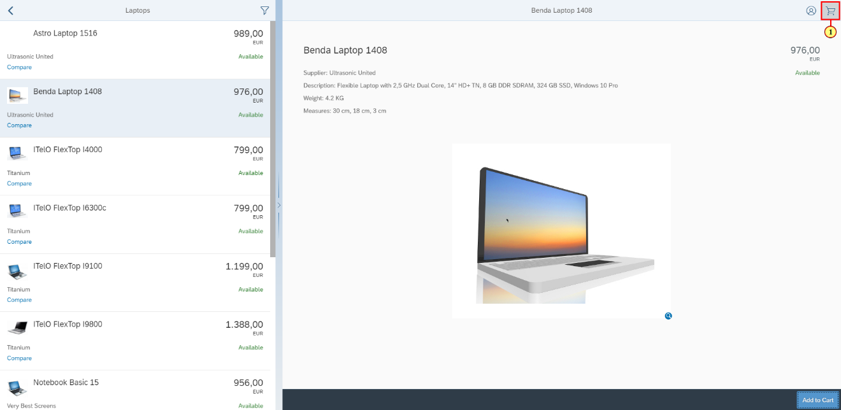

(1) Click fieldicon.

# 2.11 Shopping Cart – Proceed checkout

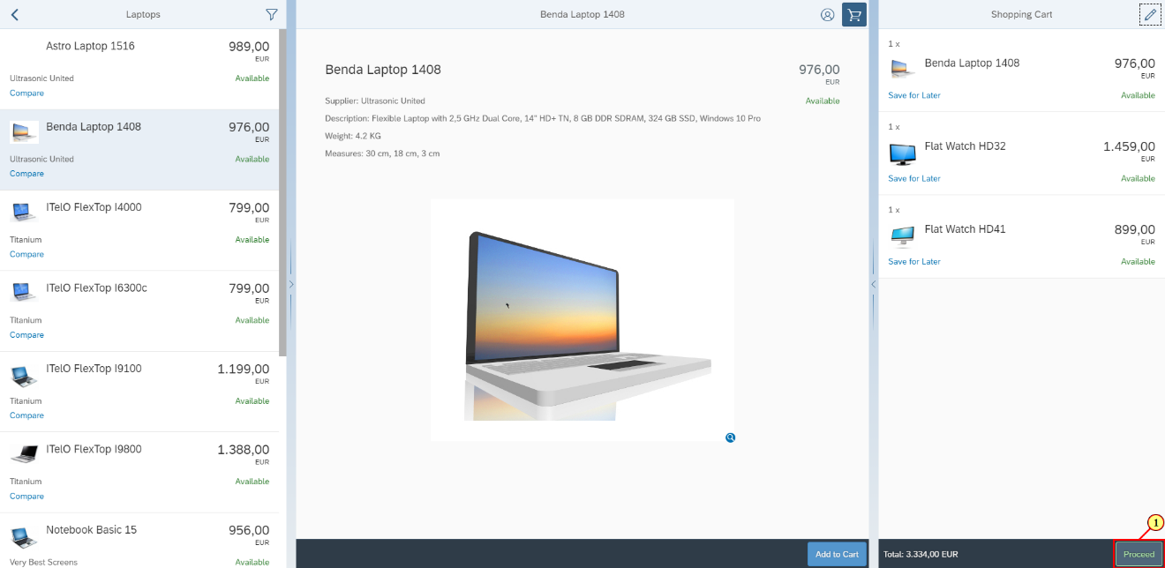

(1) Click fieldicon_83.

# 2.12 Shopping Cart – checkout step 1: items validation

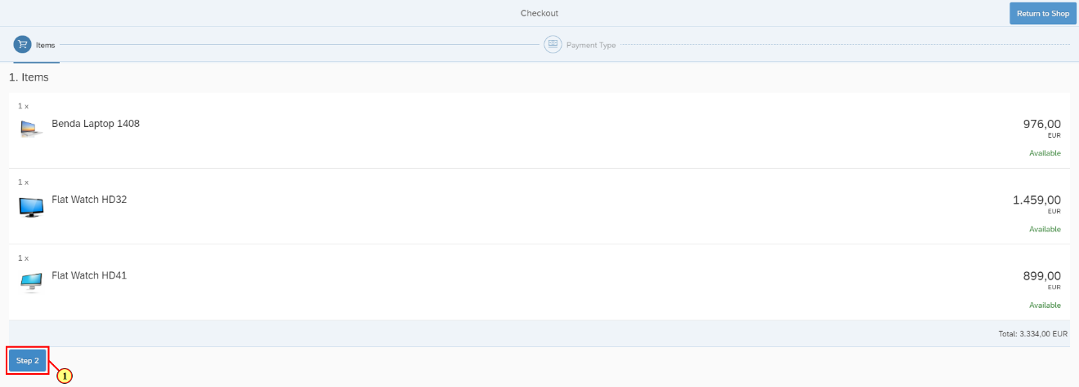

(1) Click fieldicon_91.

# 2.13 Shopping Cart – checkout step 2: payment type choice

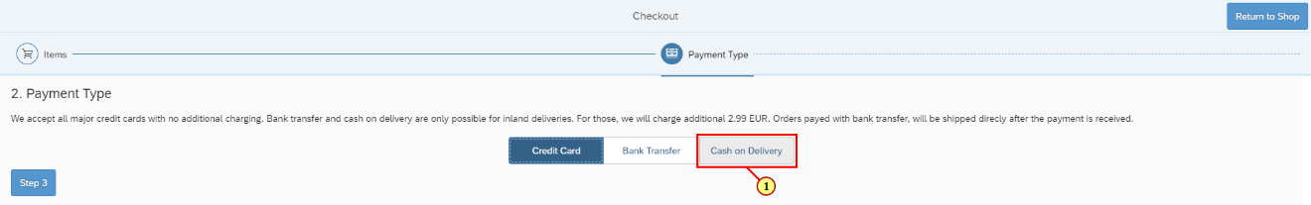

(1) Click fieldicon_103.

# 2.14 Shopping Cart – checkout step 2: payment type validation

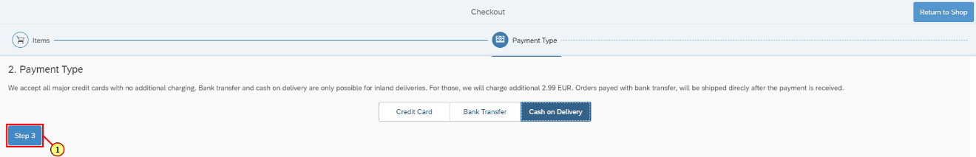

(1) Click fieldicon.

# 2.15 Shopping Cart – checkout step 3: details for cash delivery

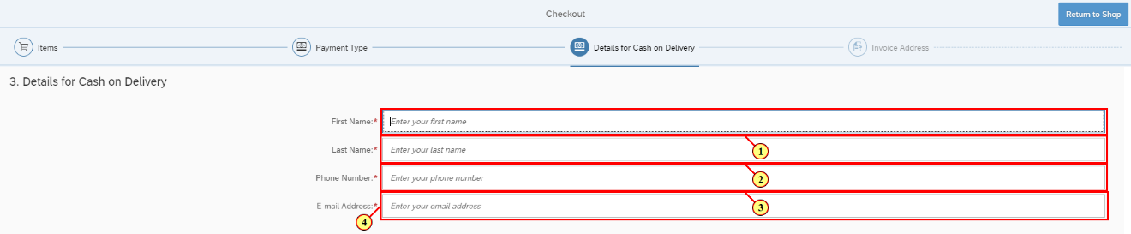

(1) Set the First Name

(2) Set the Last Name

(3) Set the Phone Number

(4) Set the E-mail Address

# 2.16 Shopping Cart – checkout step 3: details for cash delivery validation

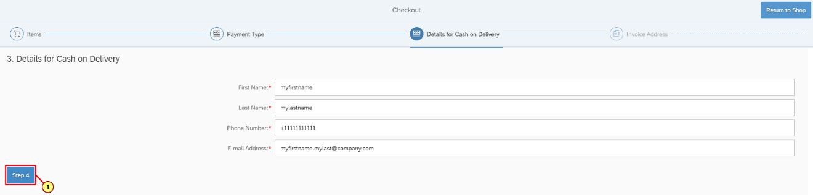

(1) Click fieldicon.

# 2.17 Shopping Cart – checkout step 4: Invoice address

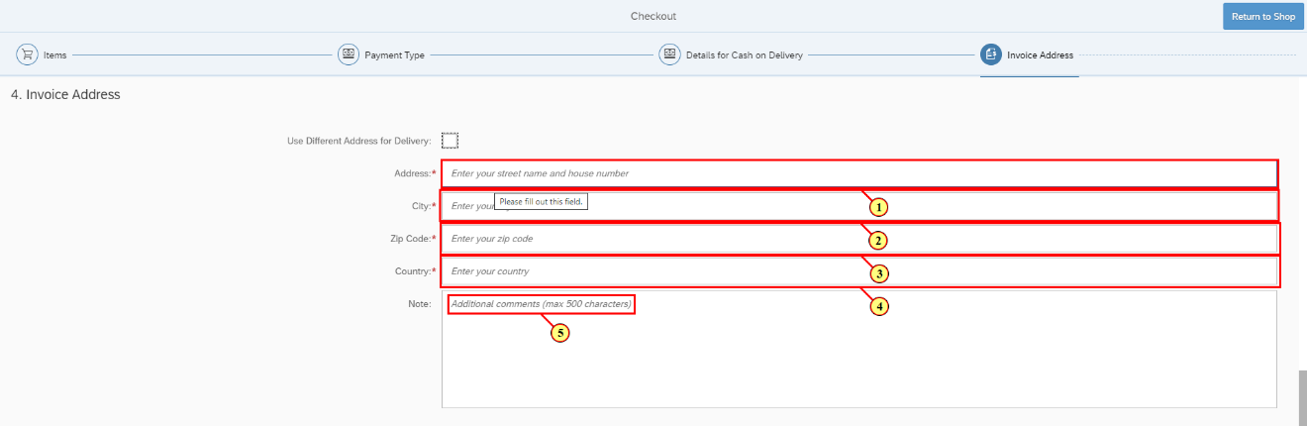

(1) Set the Address

(2) Set the City

(3) Set the Zip Code

(4) Set the Country

(5) Set a Note

# 2.18 Shopping Cart – checkout step 4: Invoice address validation

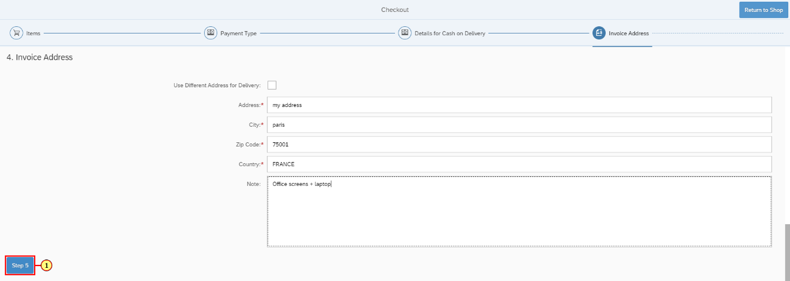

(1) Click fieldicon.

# 2.19 Shopping Cart – checkout step 5: Delivery type choice

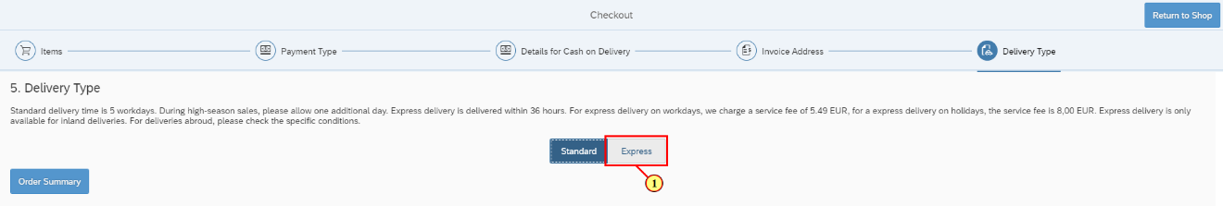

(1) Click fieldicon_109.

# 2.20 Shopping Cart – checkout step 5: Delivery type validation

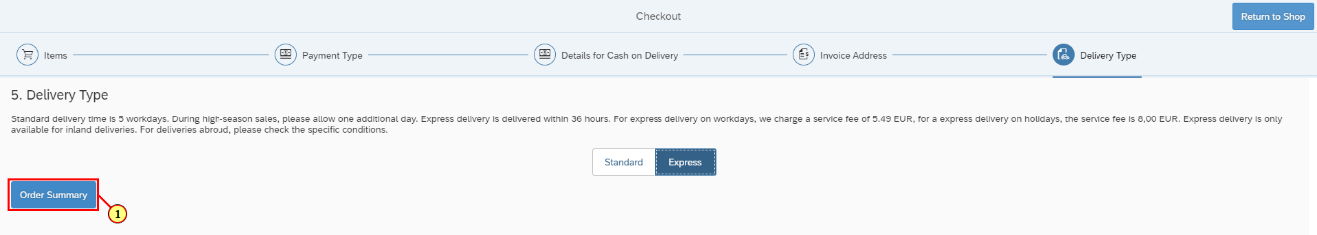

(1) Click fieldicon_119.

# 2.21 Shopping Cart – order summary

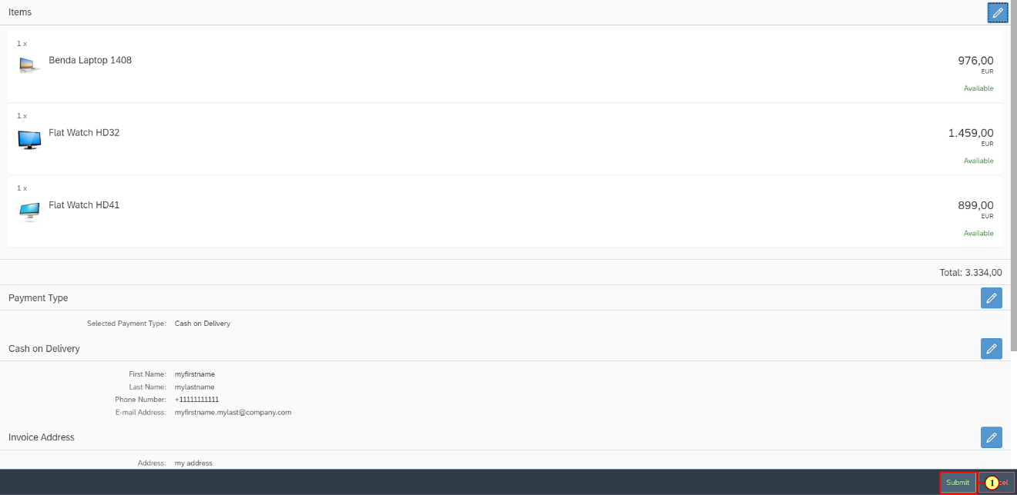

(1) Click fieldicon.

# 2.22 Shopping Cart – order confirmation

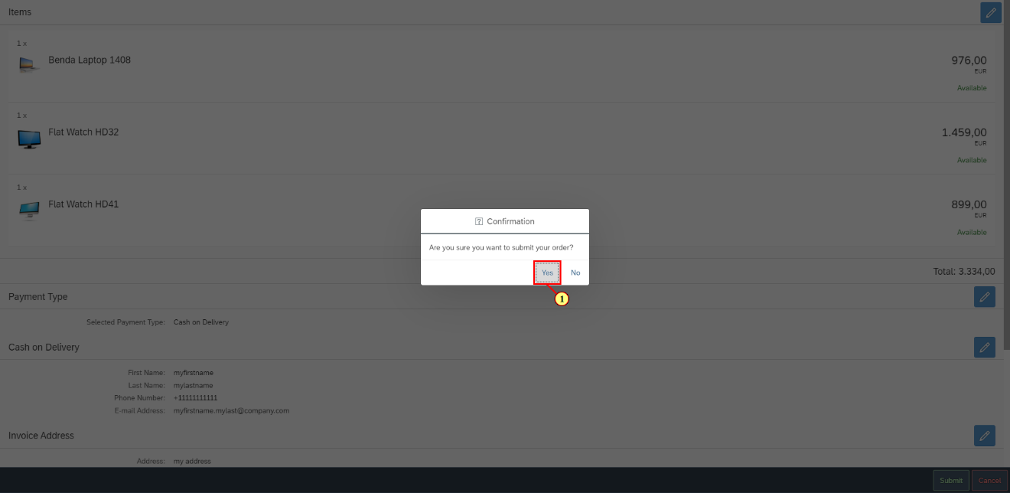

(1) Click fieldicon_125.

# 2.23 Shopping Cart – order completed

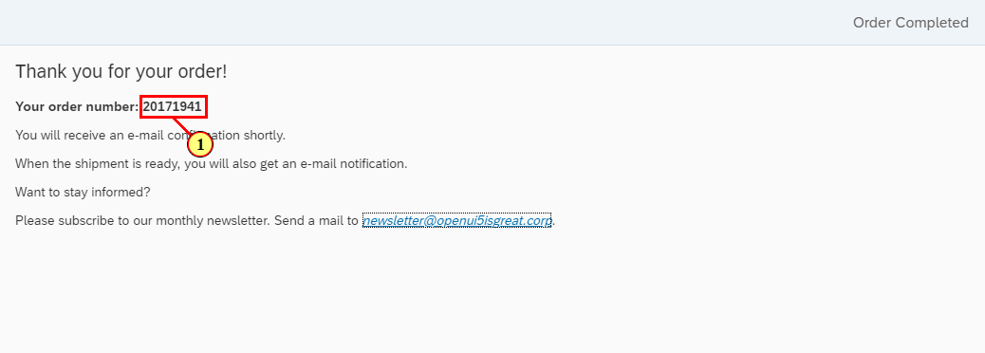

(1) Click and select the order number.

# 2.24 Shopping Cart – select order number

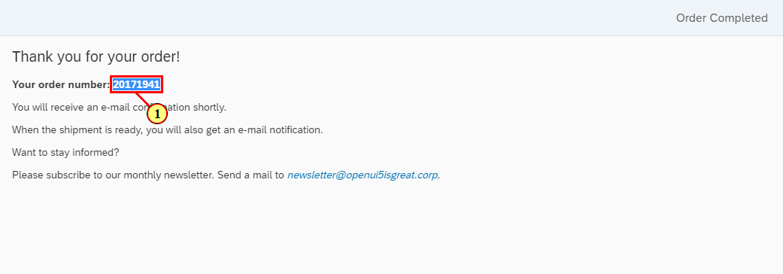

(1) Copy and paste the order number **20171941**, we will need it in next steps

# 2.25 Shopping Cart – return to shop

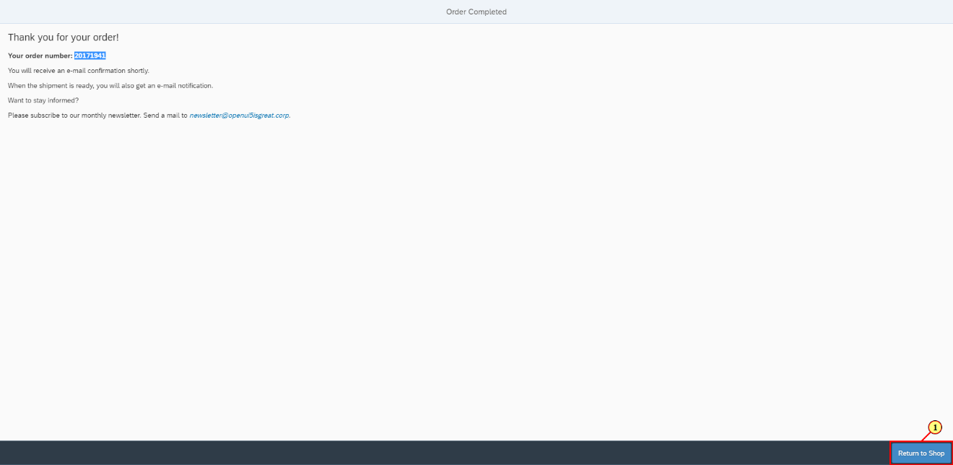

(1) Click fieldicon_152.

# 2.26 Shopping Cart – home

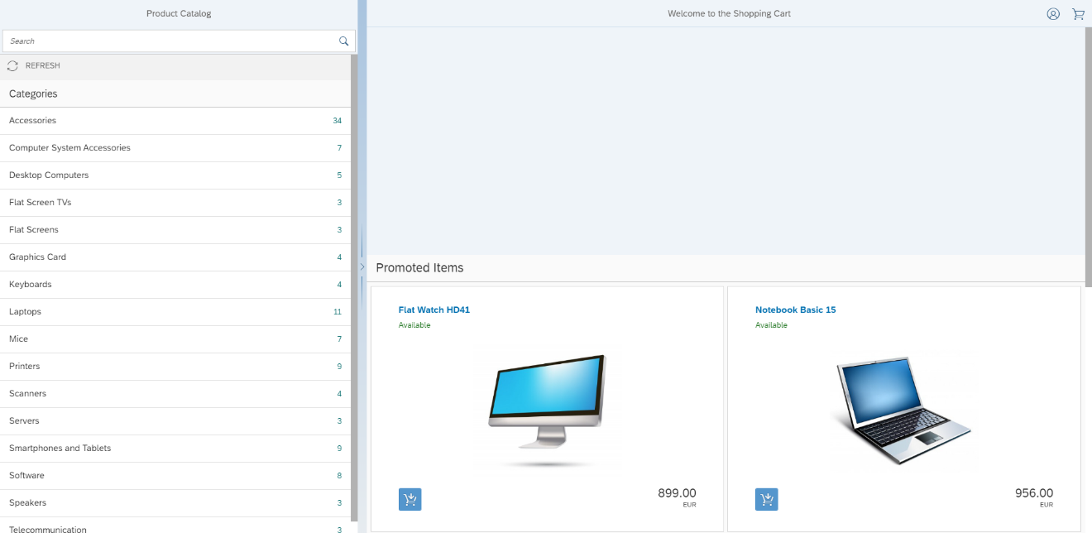

# 3 Email

Now that the order has been completed, its time to use the order number.

# 3.1 Email – send the order number

Using a custom script, send the retrieved order number from **step 2.24** and send it by e-mail.

You can use the provided blog post to do that.

# 4 Summary

You have completed the exercise !